### Medical model

Recall that for the medical model, we have four possibilities:

* True positive when the patient is sick and we correctly diagnosed him as sick
* True negative when the patient is not sick and we correctly diagnose them as not sick
* False positive when the patient is healthy and we incorrectly diagnose them as sick
* False negative when the patient is sick and we incorrectly diagnose them as healthy

#### **Quiz 1**

Which one do you think is worse, a false positive or a false negative? In other words, what is the worst mistake, to misdiagnose a healthy patient as sick or a sick patient as healthy? Respond to the exercise below.

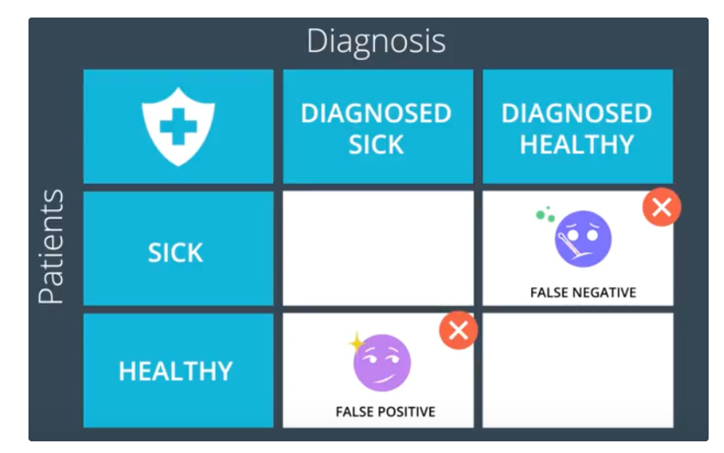

### **Quiz Question**

In the medical example, what is worse, a False Positive, or a False Negative?

1. False Positive
2. False Negative

### Spam email model

Imagine we have two emails: one non-spam from our grandma telling us she baked cookies and one spam from a questionable source. Recall that for this model, we again have four possibilities:

* True positive when the spam e-mail gets correctly sent into the spam folder
* True negative when our grandma's e-mail gets correctly sent to the inbox folder
* False positive when grandma's email accidentally gets sent to the spam folder
* False negative when a spam email accidentally gets sent to our inbox

#### **Quiz 2**

Which one do you think is worse, a false positive or a false negative? In other words, what is a worse mistake, to accidentally send your grandma's email to the spam folder or to accidentally send the spam email into your inbox?

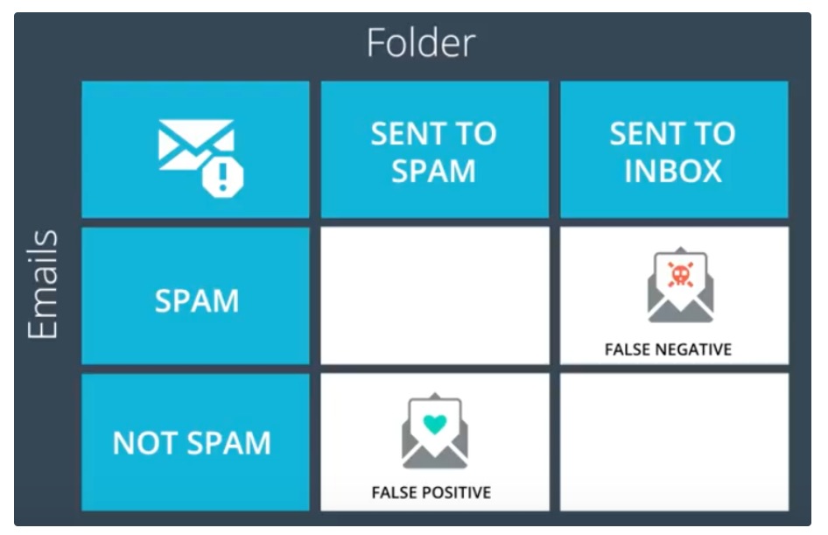

### Quiz Question

In the spam detector example, what is worse, a False Positive, or a False Negative?

1. False Positive
2. False Negative